Pennine Megagames presents...

SENGOKU
Saturday 28 November
Sheffield Workstation, 15 Paternoster Row, Sheffield, S1 2BX
Registration starts at 9.30am. Please arrive by 10am at the latest.

Dear

Please find enclosed all the information to enable you to play Sengoku. There is also a clan briefing sheet, to give you an idea of the situation in Japan at the start of play. More specific information, including both individual and clan objectives, will be distributed on the day, along with clan resources (see the next page).
More detailed background information is on the website for those who want their quota of ‘fluff.’
We would advise you to look into the tea ceremony and haikus before the day, although some information will be provided to help you if necessary.
Hot water, plus tea and coffee, will be provided. There are a number of local sandwich shops and cafes, but be aware that there is no break in play for lunch.

How to get to the venue
Showroom Workstation is 5 minutes’ walk from the train station and 10 minutes’ walk from the main bus interchange. To plan your journey by bus: www.travelsouthyorkshire.com
There are bicycle racks directly outside the Showroom and Workstation entrances on Paternoster Row.
Showroom and Workstation is close to the M1 Parkway and Sheffield city-centre. There is limited on-street parking on Paternoster Row and Shoreham Street and several car parks in the vicinity.
Other car parks in the vicinity include:
Euro Park Matilda Street S1 4QW (£5/day), Sheffield Pay and Display, Arundel Street (£5/day) S1 2NT,
Sydney Street Car Park, S1 4EG and Sheffield Station Car Park, Turner Street, S1 4AA
Also, check www.ncp.co.uk, www.q-park.co.uk if necessary.
What you will find in your clan box
In your clan box you will find:
- A clan castle sign and stand to display it on the table
- Coloured labels for players
- A map of Japan
- Coloured figures to mark yours and enemy dispositions on the map
- Your starting rice (white) and gold counters.
- Post-its and pens

First Steps – start sticking!
Daimyo – Two coloured labels, one on each shoulder
Taisho (General) – Two coloured labels, on the right shoulder
Heir – Two coloured labels, on the left shoulder
Chamberlain – One coloured label, on the left shoulder
Clan Elder – One coloured label, on the right shoulder
Next, give yourself a clan label and put your name AND AGE (this is important) on a blank sticker.

You’re ready to get started…
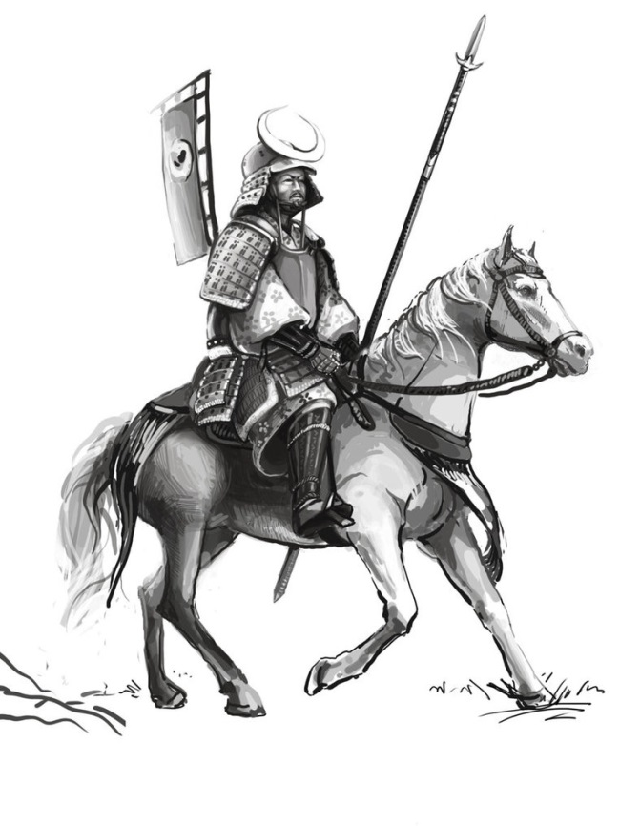
Sengoku Clans Briefing – common knowledge at this time.
This game is set a short time after the initial briefing, which is found on the website. There have been some key changes which are detailed below. Please note that non-player daimyos, particularly in the north and south, have their own agendas, but will not blithely ignore a threat from player clan.s.

In the north…
Clan Uesigi - under the new leadership of their young Daimyo they have reclaimed Kozuja from Hojo. This has caused some consternation amongst the Hojo clan, who had assumed their dominance over rivals was complete.
Clan Hojo – following the loss of their Kozuja, less than a year after its capture, they are expected to collect forces to retrieve it as soon as possible.
Clan Akita – traditionalists to a man, they have stayed out of the Hojo-Uesigi struggle for dominance and appear to have little interest in moving from their remote position at this point.

In the south…
Clan Miyoshi – were consumed by an internal power struggle after the assassination of the daimyo. Their forces and influence are currently restricted to the island of Shikoku whilst the succession is determined.
Clans Sue, Otomo and Mori are attempting to exert their dominance around Kyushu and the southern tip of Honshu.
Clan Amako - trying to hold their ground after rebuffing Yamara’s attempts to seize Izomo.

And where it’s all happening…
Clan Yamara (Red) - lost Harima to Clan Ukita whilst they were themselves preoccupied with seizing Izomo. This has cost them both honour and revenue.
Ukita (Blue) – feeling buoyed by the capture of Harima and access to central Honshu. They may or may not wish to come to an arrangement with Clan Yamara.
Clan Oda (Green) - has consolidated with Clan Imagawa through marriage and their dynamic Daimyo isthe assumed leader of both clans at this point.
Clan Takeda (Yellow) – appear somewhat restricted by the mountains but last year mounted an impressive cultural display that was a topic of conversation for weeks afterwards.
Hogan Ji Temple (Purple) – is a powerful force and has been talking loudly about becoming the pre-eminent temple in Japan.
Clan Masuda (Orange) - seized Yamashiro whilst Miyoshi were in turmoil. They appear to be feeling very confident at the moment, having made considerable gains in the last two years, although their leaders lack experience.
Clan Saito – has remained independent, but it has been made known that they would seek to secure their status. Non-player Daimyo.
Sengoku – How to Play

Background
Sengoku is a slightly different megagame to many. Whilst it does involve negotiations, political scheming and military combat, it is set in a culture very different to our own and acting appropriately is fundamental to how your clan is perceived.

The game is set during a time when the 16 year-old Shogun is in exile. The Bakufu act as a form of Civil Service and will be your contacts with higher authority. They are based in Kyoto. Your team represents a samurai clan which will hope to exploit the uncertainty within the country.

Before reading your background briefing and the mechanics of the game, we suggest that you familiarise yourself with protocols, as your behaviour will be noted (and possibly rewarded) throughout the game by the umpires:
- Showing politeness to others is paramount, regardless of any dispute or machinations behind the scenes.
- Bowing is a part of culture. The deeper the bow, the greater the respect. Bear in mind your relative ranks though.
- When visiting another clan’s castle (table), you should await a bow of invitation or leave immediately.
- Physical gifts (not rice or gold) are an important part of negotiations.
- When a discussion takes place, it is incredibly rude to interrupt another person.
- Within the clan, the least senior person should start a discussion, but there should be no voting or agreement by consensus. The Daimyo is an absolute leader.
Please note that game mechanics pages have their intended audience at the top. Make sure you’ve read at least the ones which apply to you.

Within your clan the following roles exist:

Daimyo (Leader) - Should always be addressed as ’Lord’. You take personal responsibility for the decisions made and should remain at the castle.
Taisho (General) - Raising troops and leading them. Taking responsibility at the map table.
Samurai (Clan Elder) - Keeps track of the status of the clan and its interests.
Samurai (Heir) - These are often family members, but may be adopted. Can fulfil other roles.
Chamberlain - Acts as a diplomat and go-between.
They may not all be played at the start, which will allow for some changes when, ‘ahem’ mortality catches up with players.
Rank and Awards

Daimyo start the game as Constable of their Home province. This means they are officially responsible for taxation, raising armies and dispensing justice. They may control other provinces and fulfil those responsibilities, but it has not yet been recognised at court.

During the game they may gain titles through rendering services and inheritance:
· The Shogun may appoint Governors and Constables (sometimes the same person) of provinces
· Court Rank, nominated by Bakufu, Shogun or Emperor. 1st is the highest rank.

Governors are normally court nobility, but exceptional service may be rewarded.
DO NOT make up titles you don’t have— it will have unpleasant consequences

Precendence - seniority is determined by:

· Rank: Emperor - Shogun - Holders of Court Rank - Daimyo - Heir - The Rest
· The existence of an illustrious ancestor
· Age

Control Umpires

There are a number of people roaming around today, helping to run the game.
Team Control—your main point of contact. NOTHING HAPPENS WITHOUT THEIR KNOWLEDGE. Inform them of any deals or treaties. They will provide relevant information, but you should rely on them for all information. Check with them first regarding any problems. Please do not wander round umpires, looking for the ‘right’ answer…
Map Control—they will supervise activity on the map, provide advice and resolve issues. Ordinarily, only your general will interact with them.
Non-Player Daimyo Control— will act for unplayed lords. Do not view unplayed lands as a ‘secure flank’ or easy pickings. They will be acting in their best interests.
Intelligence Control—you do not who this is, as they work through team control.
Game Control—managing the game and final court of appeal

How the game works – Everyone read this

The game will last for approximately 12 turns.
Each turn is a season: there are four seasons in a year, broken down (unsurprisingly) as follows:
WINTER : SPRING : SUMMER : AUTUMN

No campaigning is permitted in the winter and all armies disband at that time (samurai return to their homes, foot soldiers disperse to rural estates, etc). You should remain in your castle during the winter turn.
This will be a shorter turn than the other seasons.

Turn Sequence
Winter | Spring | Summer | Autumn
1. No Campaigning – all armies disperse.  2. Clans stay in their castle – communication by Team Control notes.  3. Income is calculated and distributed.  4. Instructions given for Castles, Fortresses and Ostentatious Public Works. | EACH SEASON  1. ISSUE ORDERS (5 minutes). Players (usually Taisho) go to the map.  2. MOVEMENT/BATTLE PHASE (10 minutes). Any army movements and combats resolved and results fed back to clans.  3. PLAYERS DISCUSS NEXT ACTIONS (10 minutes). This is when players work out their strategy and rule their lands. Non-combatant players can view the map at this time.  4. RAISING TROOPS (5 minutes). Players announce to control how many fresh troops they are raising for NEXT SEASON  - Throughout the turn diplomatic and social visits may take place -

Income
Each Year you will receive income from your provinces and must decide what to do with it.
Your income is measured in ‘ryo’, which is an equivalent amount of gold or rice.
Each province has a rice income listed. This comes at the start of the winter season for spending.
Some provinces provide additional resources or trade, such as fishing or mining.
If you conquer a province it will produce half revenue for the first year until the new order is formalised.
It is difficult changing taxation rates and all rice is collected by team control at the end of the year, so you will need to budget.
You may convert 10% of your rice into gold if desired. Any more and there would be a glut in the market.
You may keep gold, but would not want to gain a reputation as a miser.
What Can We Spend Income On? Everyone Read this

You will find that within your clan there may be different opinions on how to spend the money. Generals will be concerned about their military reputation and waging war. Other players will have different objectives.
You may spend your ryo on:

TROOPS - 1 ryo per 1000 men. They are raised in the province which funds them and the province score is the limit on the number of men (e.g. 11 ryo province = 11000 men). Troops without a general remain in the province as a garrison, although a general passing through can take them with him. ALL TROOPS disband at the start of the winter season.
DEFENCES - Castles: 15 ryo to build, 1 year to build, 2 ryo per year to maintain (don’t forget this)
- Fortresses (Castle upgrade): 30 ryo to build, 1 year to build, 5 ryo per year to maintain.

Castles count as 5000 men; Fortresses, 10000. Casualties come off the castles and fortresses before defenders.

Damaged or abandoned castles and fortresses cost 8 and 20 ryo to re-commission. (1 year)

OSTENTATIOUS PUBLIC EVENTS (great hunt, religious festival, etc) - 1 ryo would be considered mean. Control will look at the amount spent when considering honour and prestige.

OSTENTATIOUS PUBLIC BUILDING (temple, mansion, etc) - minimum cost 5 ryo. Marked on the map, but cost 1 per year to maintain. Abandoning them will cost your reputation

FLASHY UNIFORMS FOR THE TROOPS - 1 ryo per 2000 men

LEND MONEY TO A POOR NOBLE - Court nobility have appearances to keep up, but remember it is impolite to demand repayment.

BRIBES/ASSASINS/SPIES - the more you spend does not guarantee improved results. Discuss with Team Control.

Diplomacy – Daimyo, Diplomats and Clan Elders

Social Courtesy
When negotiating you should consider the key protocols and control will be looking at those and also looking at how the following form part of your dealings with others:
- Gifts
- Haiku
- The tea ceremony

Alliances
There are two main ways to secure alliances and good behaviour:
- Marriage
- Hostages (Hostages may be player characters, but if not will be represented by a counter)
Team Control must be informed. The order of severity is as follows:
- Word of honour
- A written treaty, signed in front of a priest (or control)
- A written treaty, including the exchange of hostages (this may or may not be mutual and involves a member of the immediate family). Breaking such a treaty and losing hostages is a significant loss of honour.

Warfare - summary
You may have as many armies as you have commanders. Troops are in ‘000s.
Troop counters must be played on the map., either in provinces as garrisons or under general’s army stand (which counts as another 1000 men).
Movement is one province per point of a general’s experience. Experience moves up with every victory, to a maximum of 4.
When two armies enter the same province, they may either ignore one another or choose to fight (unless a garrison is there). An army may choose to withdraw after seeing the other army’s size or after each round of combat.
Battles are resolved by generals and can be very bloody.
Controlling Provinces
You may force the Daimyo to submit and become your vassal, taking hostages and hoping they remain loyal—this keeps the provinces income intact
OR
You may replace the existing rulers to ensure loyalty, but this will see a reduction in income for one year.
Activity at the Map – Taisho (and possibly heirs or Daimyo, if necessary)
The Layout
Provinces will be marked with a coloured counter to represent the clan they belong to.
Each clan will have a number of wooden counters with samurai figures on them.
- The squares with a flag on them represent generals and 1000 men.
- The circles without a flag represent a garrison commander.
- Black represents a Non-Player Daimyo commander/garrison.
Map Control will have a large number of wooden counters with 1000, 3000 and 5000 soldiers on them. After paying for them you place them underneath general and garrison counters. This allows for some disguising of your army’s strength, until you face an enemy.
Garrisons do not move, but their soldiers may be taken by generals who pass through their province.

Map Movement

Movement is one province per point of a general’s experience. Experience moves up with every victory, to a maximum of 4. Movement is written on an orders card.
Each campaign season at the map is split into 4 phases. Map Control will call these phases.

Phase One – 4 star generals move one province
Phase Two – 4 -3-2 star generals move one province
Phase Three – ALL generals move one province
Phase Four – 4 and 3 star generals move one province

+1 province per move if on a road.

All armies may move at least 1 province and no more than 4 in each season.

Sea crossings cost 1 ryo. If two armies wish to use the same crossing a sea battle is fought. This is as normal, but with double casualties.

Battle Sequence Taisho (Italics are optional activities) – Most generals start with 2 stars, other players one.

Step 1 – when two armies enter the same province they compare their respective strengths and both must agree to combat.

Step 2 – if combat is agreed then commanders select their tactic (Rock, Paper, Scissors). Bloody Assault (Scissors), Firm Defence (Rock), Outflank (Paper). The winner receives a +1 to their combat roll.

Step 3 – commanders may choose to commit heavily and sacrifice troops in the battle. This is a one-off reveal and NOT a bidding war.Sacrifice up to 3,000 more than the enemy, +1 to the combat roll. Sacrifice 4,000 or more and receive +2. ALL sacrificed troops are then removed from play.

Step 4 – commanders may choose to risk their reputation (and life) in battle and roll 1 dice for each star they currently have:
1 = Take a wound AND lose a star (no lower than 1 star), 2 = Take a wound, 3 = no effect, 4-5 = +1, 6 = +2

Step 5 – add remaining modifiers:
In Home Province +1
Outnumber 3:2 +1 (0 if in mountains)
Outnumber 2:1 +2 (+1 if in mountains)
Outnumber 3:1 +3 (+2 if in mountains)
Outnumber 4:1 or more +5 (+3 if in mountains)

Step 6 – roll 2d6 each and add any modifiers as above. Compare results.

Difference of 0-2: Inconclusive result. Each army inflicts 1,000 casualties per 8,000 in their army.
Difference 3-5: Minor Victory. Winning general receives star and inflicts 1,000 casualties per 3,000 in their army.
Loser inflicts 1,000 casualties per 5,000 in their army. Loser may fight another battle in the province if they sacrifice 1,000 men in a rearguard action. Otherwise they must retreat from the province, preferably to where they came from.
Difference 6+: Major Victory. Winning general receives star and inflicts 1,000 casualties per 2,000 in their army.
Loser inflicts 1,000 casualties per 6,000 in their army. They must retreat from the province, preferably to where they came from.

